Configuração Webpack

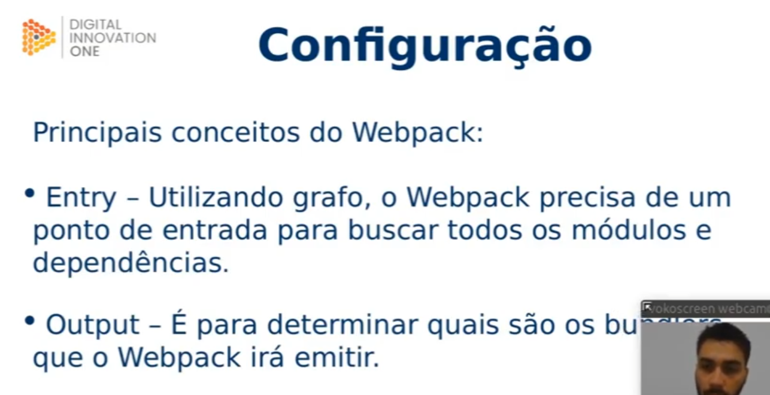

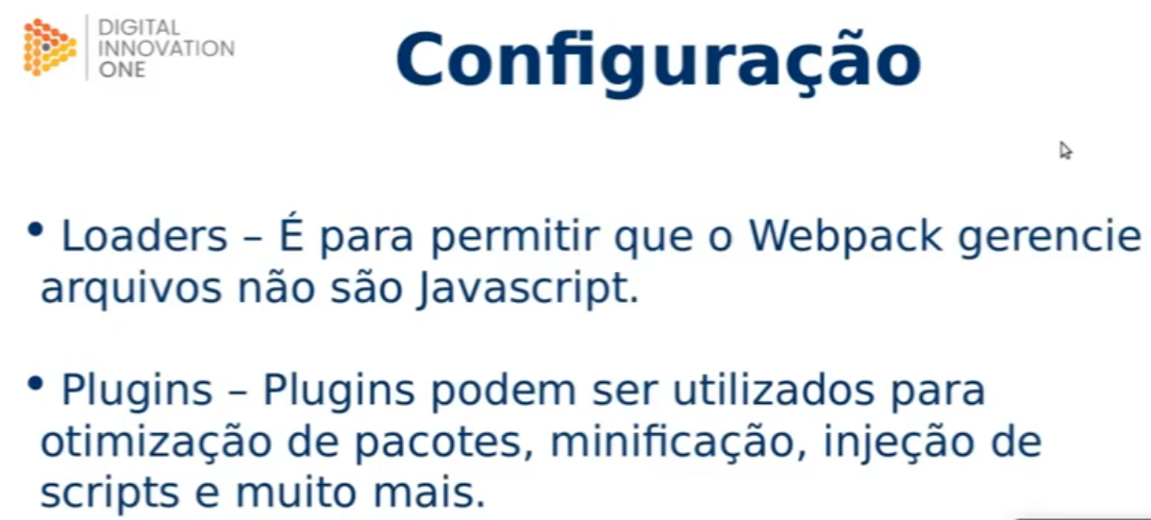

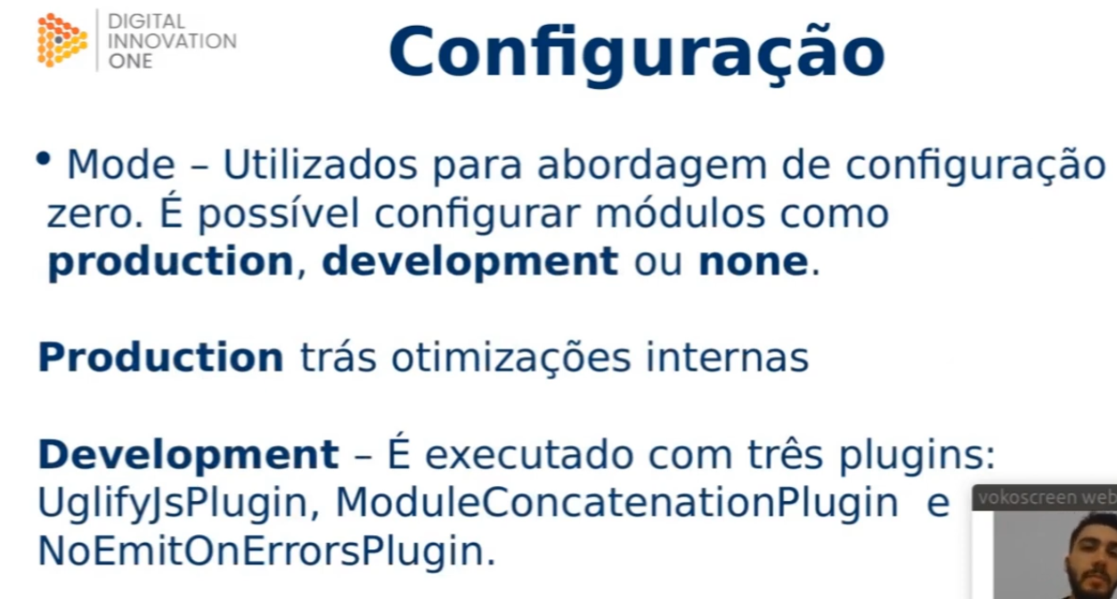

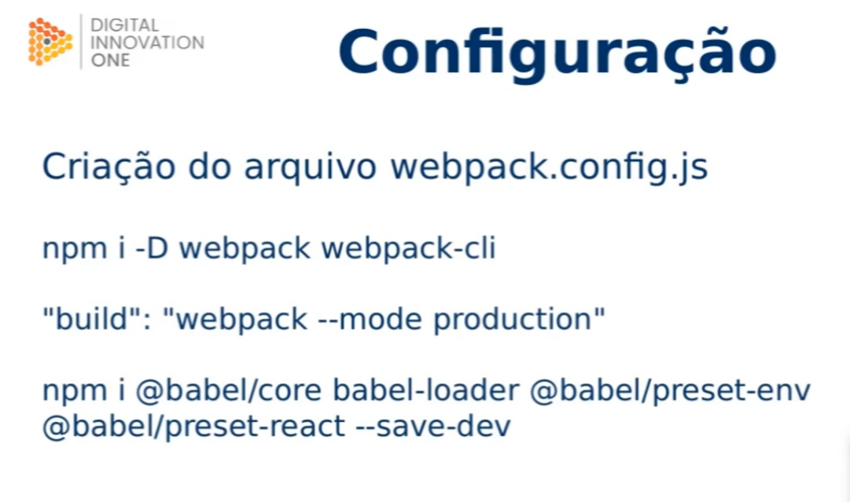

Npm i @babel/core babel-loader @babel/preset-env @babel/preset-react –save-dev

npm install --save-dev html-webpack-plugin